

**Enhanced SmartDrive40**

**MDS40B**

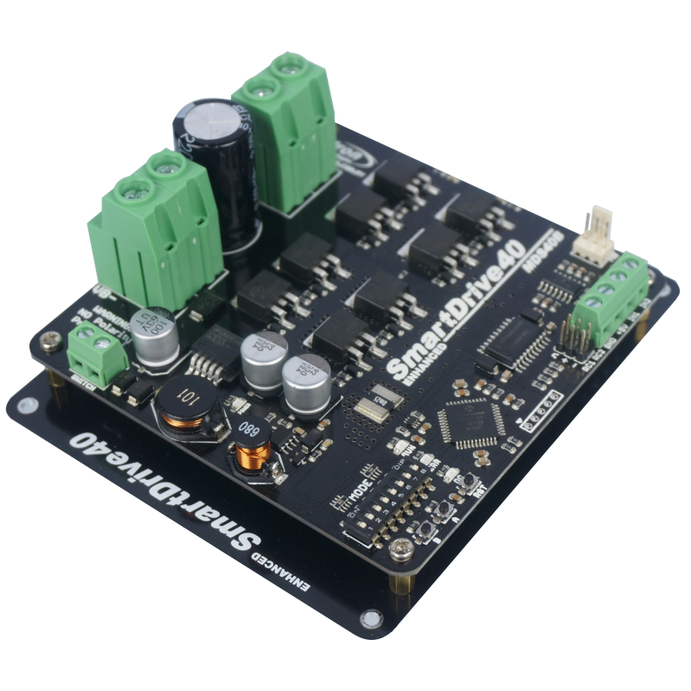

**User's Manual**

**Rev 1.0**

**December 2015**



**INDEX**

1. Introduction  3
2. Packing List 4
3. Product Specifications 5
4. Board Layout  6
5. Power Supply 9
6. Motor Connection 10
7. Safety Features 11
8. Input Modes 12
   1. RC Input Mode 14
   2. Analog/PWM Input Mode 16
   3. Simplified Serial Mode 18
   4. Packetized Serial Mode 20
9. Warranty 22

**1. INTRODUCTION**

Enhanced SmartDrive40 is an enhancement version of SmartDrive40 which is designed to drive medium to high power brushed DC motor with current capacity up to 80A peak and 40A continuously. MOSFETs are switched at 16 KHz to ensure quiet operation and no annoying whining sound. Besides, it also equipped with a microcontroller unit to provide smart features such as multiple input mode, current limiting and thermal protection.

Enhanced SmartDrive40’s feature makes driving a robot with differential drive a truly plug and play experience.

Some of the features for Enhanced SmartDrive40 are summarized as below:

* Bi-directional control for dual brushed DC motor.
* Support motor voltage from 10V to 45V.
* Maximum current up to 80A peak (1 second), 40A continuously.
* On board MOSFETs are switched at 16 KHz for quiet operation.
* Battery low voltage indicator.
* Battery over voltage indicator.
* Thermal protection.
* Multiple input modes: RC, Analog, PWM, Simplified Serial and Packetized Serial.
* On board push buttons for fast test and manual operation.
* **No polarity protection for V motor**.

**2. PACKING LIST**

Please check the parts and components according to the packing list. If there are any parts missing, please contact us at sales@cytron.com.my immediately.

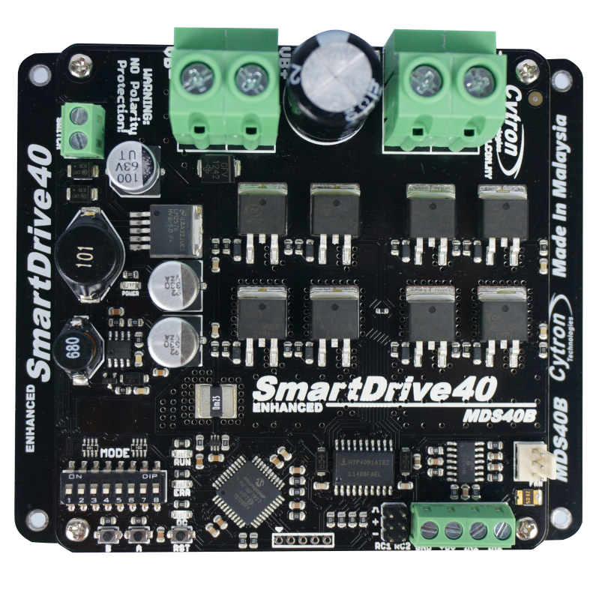

* 1 x [Enhanced SmartDrive40](http://www.google.com/url?q=http%3A%2F%2Fwww.cytron.com.my%2Fp-mdds10&sa=D&sntz=1&usg=AFQjCNGtiVAFfOgBm36WTfca2aabksoTng) with top and bottom cover.
* 2 x [2561 Servo Extension cable](http://www.cytron.com.my/p-wr-ex-2561-03)

**3. PRODUCT SPECIFICATIONS**

Dimension:

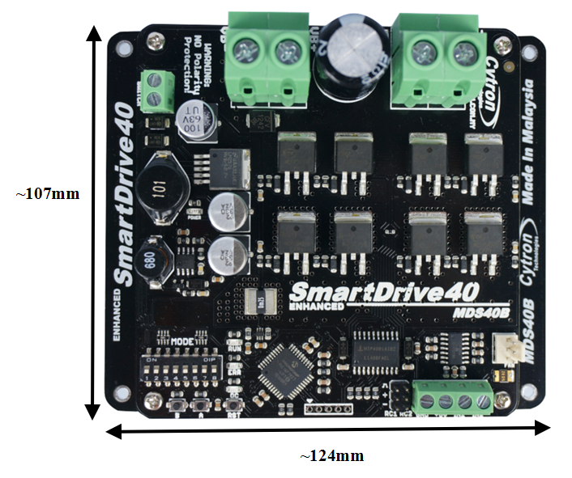

Absolute Maximum Rating of Enhanced SmartDrive40

|  |  |  |  |  |  |
| --- | --- | --- | --- | --- | --- |
| **No** | **Parameters** | **Min** | **Typical** | **Max** | **Unit** |
| 1 | Input Voltage (Motor Supply Voltage) | 10 | - | 45 | V |
| 2 | IMAX (Maximum Continuous Motor Current)* | - | - | 40 | A |
| 3 | IPEAK – (Peak Motor Current) ** | - | - | 80 | A |
| 4 | VIOH (Logic Input – High Level) | 1.3 | - | 5 | V |
| 5 | VIOL (Logic Input – Low Level) | 0 | - | 0.7 | V |
| 6 | 5V Output Current | - | - | 500 | mA |

*\* Depends on the room temperature.*

*\*\* Must not exceed 1 second.*

**4****. BOARD LAYOUT**

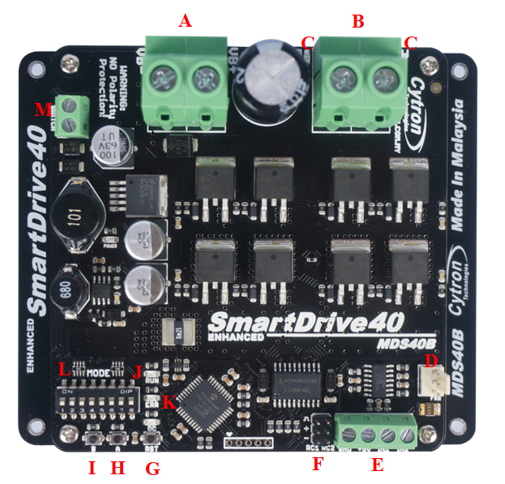

|  |  |
| --- | --- |
| **Label** | **Function** |
| **A** | **Power Supply Terminal block** |
| **B** | **Motor Terminal Block** |
| **C** | **Motor LED Indicator** |
| **D** | **Fan Input Pin** |
| **E** | **Analog/PWM/Serial Input Terminal Block** |
| **F** | **RC Input Pin** |
| **G** | **Reset Button** |
| **H** | **Motor Test Button** |
| **I** | **Motor Test Button** |
| **J** | **Run LED** |
| **K** | **Error (ERR) LED** |
| **L** | **Mode Selection DIP Switch** |
| **M** | **Power Switch Terminal Block** |

**FUNCTION Description:**

**Motor Terminal Block**

Connect to motor at your mobile robot. User can screw to lock the wire to the terminal block or solder the wire directly to the pad at bottom layer. Please use wire with proper thickness to support the expected current.

**Power Supply Terminal Block**

Connect to power source. User can screw to lock the wire to the terminal block or solder the wire directly to the pad at bottom layer. **No polarity protection**, please double check before power up. Please use wire with proper thickness to support the expected current.

**MotorLED Indicator**

Indication for current flow and direction for motor. If LED A turns on, means current flows from output A to B. Vice versa.

**Power Switch Terminal Block**

Switch for power up MDS40B’s microcontroller and logic circuit. This switch is ON by default.

**Run and Error LED**

Run LED will turn on when motor is running.

Error LED

|  |  |  |
| --- | --- | --- |
| **Number of Blinks** | **Error** | **Description** |
| Off | No Error | No error has been detected. |
| 2 | Input Error | Invalid or no input detected. |
| 3 | Under Voltage | The battery voltage is low. |
| 4 | Over Voltage | Supply voltage is over the limit. MDS40B will not operate. |
| 5 | Over Temperature | Board temperature is high. |

**Test Button**

Fast test to check driver functionality for motor. If A is pressed, current flows from output A to B. Vice Versa.

**Mode Selection DIP Switch**

User can select different input mode by setting the DIP switch.

**RC Input Pin**

This pins specially for RC receiver input wire. RC1 for forward/reverse and RC2 for steering.

**Analog/PWM/Serial Input Terminal Block**

|  |  |  |
| --- | --- | --- |
| **No** | **Pin Name** | **Description** |
| 1 | GND | Ground. |
| 2 | 5V | +5V output. **Do not** connect to another 5V source. |
| 3 | IN1 | Input 1. |
| 4 | IN2 | Input 2. |

*Please refer to INPUT MODE section for more detail.

**5****. POWER SUPPLY**

Enhanced SmartDrive40 supports input voltage ranges from 10V to 45V. The recommended power sources are:

* 9 – 18* cells NiMH or NiCd battery.
* 3 – 6** cells LiPo or Li-Ion battery.
* 10V – 45V sealed lead acid battery.
* 10V – 45V power supply (**Must be in parallel with a battery with same voltage**).

*can up to 30 cells, but the battery low voltage warning only works for up to 18 cells.

**can up to 10 cells, but the battery low voltage warning only works for up to 6 cells.

The power source can be connected to Enhanced SmartDrive40 either via the terminal block, or soldered directly to the pad at the bottom layer. **There is no polarity protection on MDS40B, please double check the connection before connecting to power source.**

|  |
| --- |
| **NOTE:**   1. If a power supply that cannot sink current is being used (example: bench top and AC to DC switching power supply), the input voltage will rise when the driver is regenerating (motor is slowing down). Thus, it is important to connect a battery with same voltage in parallel with the power supply to absorb the current generated by the motor. Else, the input voltage might rise to a level where Enhanced SmartDrive40 will be destroyed permanently or the power supply trigger protection mode. |

**6****. MOTOR CONNECTION**

Similar to the power supply, connection to the motor can be made either via the terminal block, or it can be soldered directly to the bottom layer pad.

For Mixed mode, especially for RC input mode (or [Breakout board with Joystick soldered](http://www.cytron.com.my/p-bb-psj)), each terminal block must be connected to the same side of the motor. For example, **left terminal block connected to motor LEFT and right terminal block connected to motor RIGHT**. User can further test it by controlling the motor by using RC controller. If the motor give wrong direction, reverse the polarity of the motor connection at the terminal block.

**7****. SAFETY FEATURES**

Enhanced SmartDrive40 incorporates some safety features which make it robust and reliable motor driver. Below are the detailed descriptions for each feature.

1. **Input Error (Error LED blinks 2 times)**

Every time Enhanced SmartDrive40 is power up, the input data must be ‘stop’ (for RC, Analog, PWM input mode). This feature prevent the driver from sudden run, especially when the driver accidently reset.

1. **Under Voltage Warning (Error LED blinks 3 times)**

Upon power on, Enhanced SmartDrive40 will automatically detect the number of cells for the battery. If it is set to LiPo, when the input voltage falls below 3.0V per cell during operation, the error LED will blink to warn the user. However, the power to the motor will be maintained and will not be cut out. Thus, it is user’s responsibility to stop the motor driving and replace battery to avoid further damage to the battery. If other types of battery is used to power the board (e.g NiMH, NiCD, SLA), the under voltage warning will still be shown. In this case, user may ignore the warning and he/she needs to estimate when to replace the battery by him/herself.

1. **Over Voltage Protection (Error LED blinks 4 times)**

If over voltage is detected (> 45V), Enhanced SmartDrive40 will not operate.

1. **Over Temperature Protection (Error LED blinks 5 times)**

Enhanced SmartDrive40 is equipped with a temperature sensor to monitor its operating temperature. It will gradually lower down the duty cycle percentage base on the temperature as shown below:

|  |  |
| --- | --- |
| **Temperature Range (oC)** | **Current (A)** |
| < 50 | 80 |
| 50 – 70 | 50 |
| 70 – 100 | 45 |
| 100 – 110 | 40 |
| > 110 | 35 |

|  |
| --- |
| **Note:** MDS40B does not come with polarity protection, please double check the connection before powering up. |

**8****. INPUT MODE**

When the Enhanced SmartDrive40 is powered up, RUN LED, ERR LED and OC LED will running once. After that, the input mode will be read from the DIP switch and retained as long as the driver is powered. If you wish to change the input mode, you will need to change the setting on the DIP switch and **press the “RST” reset button**, or power cycle the driver (Turn it off and turn it on again).

Enhanced SmartDrive40 supports four different types of input mode (RC, Analog, PWM and Serial). The DIP switch settings for each mode and the function for input pin are summarized on the following page.

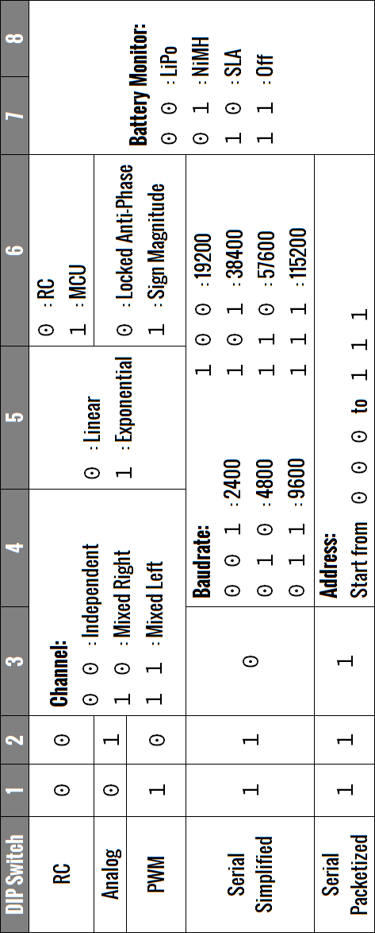

**8****.1 RC INPUT MODE**

In RC input mode, the speed and direction of the motor is controlled by the signal from the standard hobby radio control transmitter and receiver, or a microcontroller generating the similar signal.

|  |
| --- |
| **NOTE:** The RC transmitter must be ON before power up the Enhanced SmartDrive40. |

RC Input mode is selected by setting the **SW1 & SW2** to **0 (Down)**. SW3 – SW6 can be configured depending on the requirement of the user.

|  |  |  |
| --- | --- | --- |
| Input Mode | **SW1:SW2**  00 | **RC Input Mode** |
| Single/Mix Mode | **SW3:SW4**  00  10  11 | **Independent** – The motor speed and direction are controlled by a single RC channel connected to Input 1. Motor stops when the input signal is at the center point. Input 2 is not used in this mode.  **Mixed Right** – This mode should be selected for the right motor of the robot differential drive system. Input 1 controls the overall speed as well as forward/backward movement of the robot. Input 2 controls the left/right or pivot movement of the robot. In right mix mode, the motor will be slowed down when the robot is commanded to turn right and vice versa.  **Mixed Left** – This mode should be selected for the left motor of the robot differential drive system. Input 1 controls the overall speed as well as forward/backward movement of the robot. Input 2 controls the left/right or pivot movement of the robot. In left mix mode, the motor will be slowed down when the robot is commanded to turn left and vice versa. |
| Exponential Mode | **SW5**  0  1 | **Off** – The speed is linear with the input signal. This is for low to medium speed motor.  **On** –The response to input is exponential and thus soften the control around the center zero speed point. This is suitable for high speed and very sensitive motor. |
| MCU Mode | **SW6**  0  1 | **Off** – The center point will be calibrated upon power up. Timeout occurs after lost of signal for 100ms and the motor will be stopped for safety purpose.  **On** – The center point is fixed at 1.5ms and the timeout feature is disabled. Motor will continue to run with previous speed if new signal is not detected. This is useful when a microcontroller is used to control the motor. The microcontroller does not need to send the pulse continuously to the Enhanced SmartDrive40. Instead, it only needs to send a single pulse when the speed or direction of the motor needs to be changed. |

0 – OFF 1 – ON X – Don’t Care

Figures below show the connection in RC mode for Single Channel Mode. Input 1 is connected to either a RC Receiver or a microcontroller generating the RC pulse.

RC Mode with RC Transmitter/Receiver (Independent), DIP switch

1 2 3 4 5 6 7 8

**0 0 0 0 0 0 0 0**

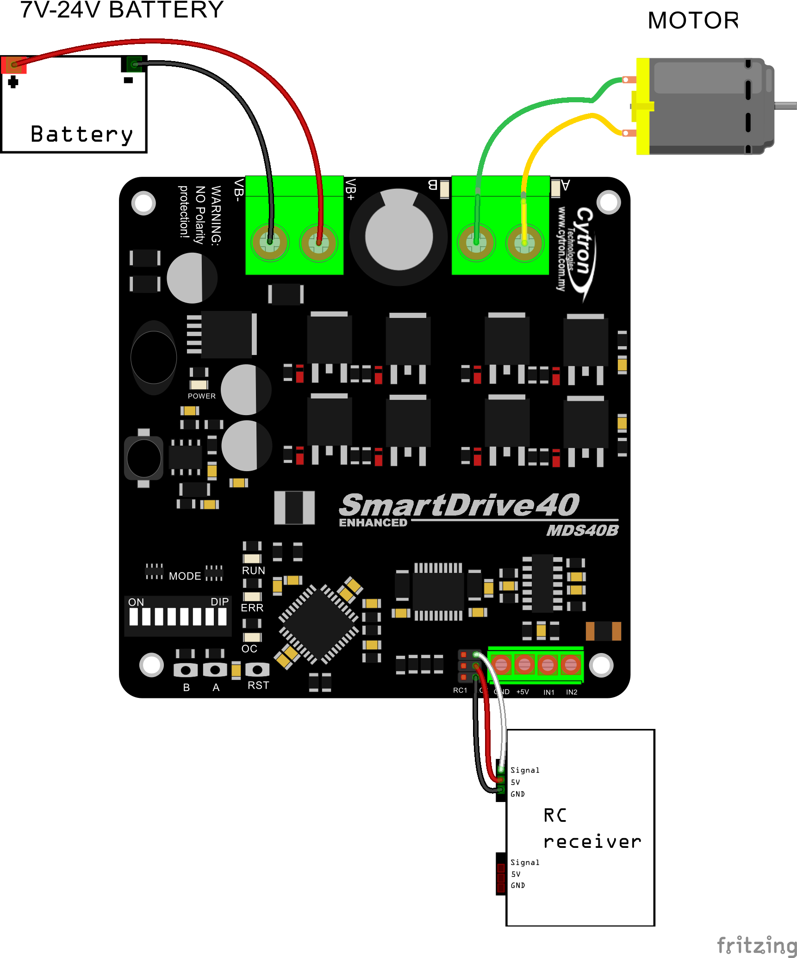

RC Mode with RC Transmitter/Receiver (Mixed Right), DIP switch

1 2 3 4 5 6 7 8

**0 0 1 0 0 1 0 0**

RC Mode with RC Transmitter/Receiver (Mixed Left), DIP switch

1 2 3 4 5 6 7 8

**0 0 1 1 0 1 0 0**

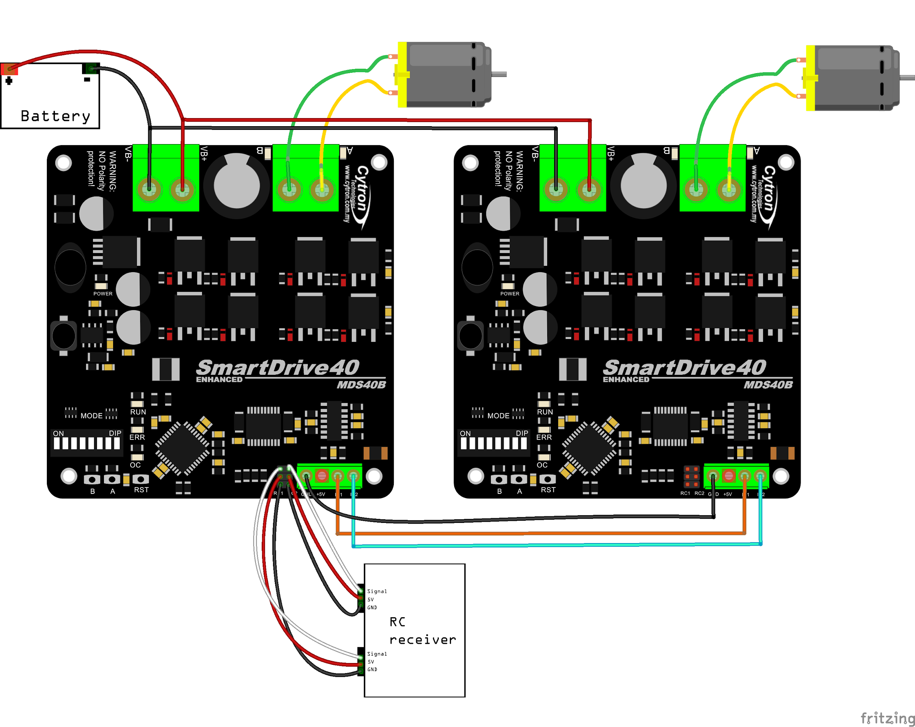

**8****.2 ANALOG/PWM INPUT MODE**

In Analog/PWM input mode, the speed and direction of the motor is controlled by the analog voltage or PWM signal. The valid input range is 0 – 5V and it’s very easy to control by using a potentiometer. For example, the motor can be controlled by a joystick or foot pedal with potentiometer.

|  |
| --- |
| **NOTE:** The Analog/PWM signal to stop the motor (2.5V if Sign-Magnitude mode is off, 0V otherwise) must be available when the Enhanced SmartDrive40 is turned on. Else, the driver will show Input Error until the correct signal is available. |

Analog input mode is selected by setting **SW1 to 0 (Down) and SW2** to **1 (Up)**. PWM input mode is selected by setting **SW1 to 1 (Up) and SW2** to **0 (Down)**. SW3 – SW6 can be configured depending on the requirement of the user.

|  |  |  |
| --- | --- | --- |
| Input Mode | **SW1:SW2**  01  10 | **Analog Input Mode** – The input is analog signal. The filter capacitor is not connected and the input signal is not filtered. SW1 is for Input 1 while SW2 is for Input 2.  **PWM Input Mode** – The input is PWM signal. The filter capacitor is connected and the input signal is low pass filtered to be an analog signal. SW1 is for Input 1 while SW2 is for Input 2. SW2 must be set to 0 if Sign-Magnitude mode is turned on. |
| Single/Mix Mode | **SW3:SW4**  00  10  11 | **Independent** – The motor speed and direction are controlled by a single channel connected to Input 1. Motor stops when the input signal is at the center point. Input 2 is not used in this mode.  **Mixed Right** – This mode should be selected for the right motor of the robot differential drive system. Input 1 controls the overall speed as well as forward/backward movement of the robot. Input 2 controls the left/right or pivot movement of the robot. In right mix mode, the motor will be slowed down when the robot is commanded to turn right and vice versa. SW8 must be set to 0.  **Mixed Left** – This mode should be selected for the left motor of the robot differential drive system. Input 1 controls the overall speed as well as forward/backward movement of the robot. Input 2 controls the left/right or pivot movement of the robot. In left mix mode, the motor will be slowed down when the robot is commanded to turn left and vice versa. SW8 must be set to 0. |
| Exponential Mode | **SW5**  0  1 | **Off** – The speed is linear with the input signal. This is for low to medium speed motor.  **On** –The response to input is exponential and thus soften the control around the center zero speed point. This is suitable for high speed and very sensitive motor. |
| Sign-Magnitude Mode | **SW6**  0  1 | **Locked Anti-Phase** – Motor stops when the input signal is 2.5V. Motor moves in one direction when the input is < 2.5V and in another direction when the input is > 2.5V. Recommended this mode if controlled using [Breakout board with Joystick soldered](http://www.cytron.com.my/p-bb-psj).  **Signed Magnitude** – Input 1 controls the speed of the motor. Motor stops when the input is 0V and run at full speed when the input is 5V. Input 2 is digital input and it controls the direction of the motor. |

0 - OFF 1 - ON X - Don’t Care

* Left/Right is just for reference only. Actual side of the motor may depends on the Input signal.

Figures below show the connection in analog/PWM input mode.

Analog input mode with Joystick board (Mixed), DIP switch

**DIP Switch Setting**

1 2 3 4 5 6 7 8 1 2 3 4 5 6 7 8

**0 1 1 1 0 0 0 0 0 1 1 0 0 0 0 0**

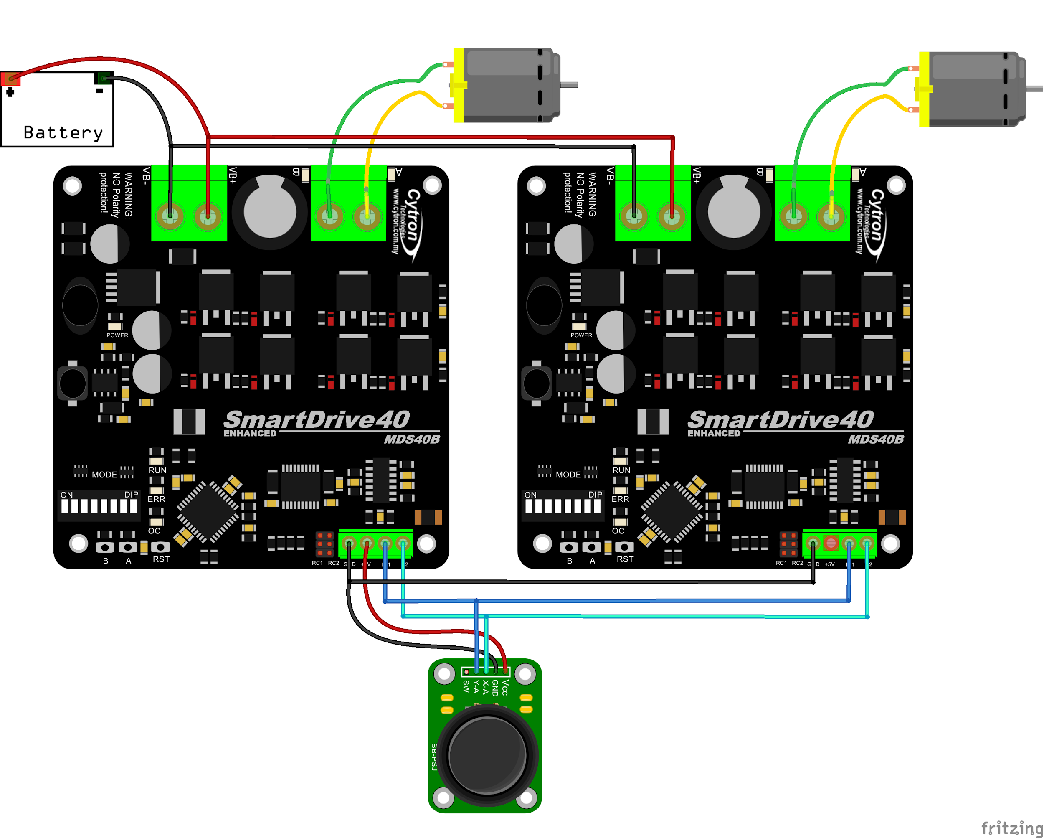

PWM input mode with microcontroller (Independent Both), DIP switch

**DIP Switch Setting**

1 2 3 4 5 6 7 8

**1 0 0 0 0 1 0 0**

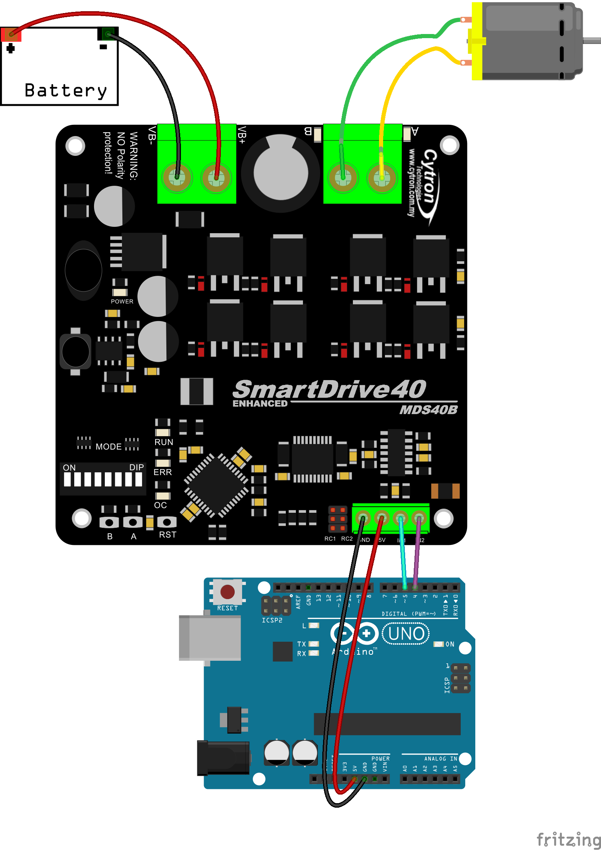

**8****.3 SERIAL SIMPLIFIED MODE**

In Simplified Serial mode, Enhanced SmartDrive40 is controlled by using the UART interface. Input 1 is the UART Rx pin and Input 2 is the Slave Select pin.

A single byte of data is all you need to control the speed and direction of the motor. Sending byte 127(decimal) 0r 0b01111111(binary) stops the motor, 0 is full reverse and 255 (decimal) is full forward.

Simplified Serial mode is selected by setting **SW1, SW2 to 1 (Up) and SW3** to **0 (Down)**. SW4 – SW6 are used to select the UART baud rate.

|  |  |  |
| --- | --- | --- |
| Input Mode | **SW1 - SW3**  110 | **Simplified Serial Mode** |
| UART Baud Rate | **SW4 - SW6**  000  001  010  011  100  101  110  111 | **Baud Rate**  1200  2400  4800  9600  19200  38400  57600  115200 |

0 - OFF 1 - ON X - Don’t Care

Figure below shows the connection to multiple Enhanced SmartDrive40 in Simplified Serial Mode.

Simplified Serial mode with microcontroller (9600bps), DIP switch

**DIP Switch Setting**

1 2 3 4 5 6 7 8

**1 1 0 0 1 1 0 0**

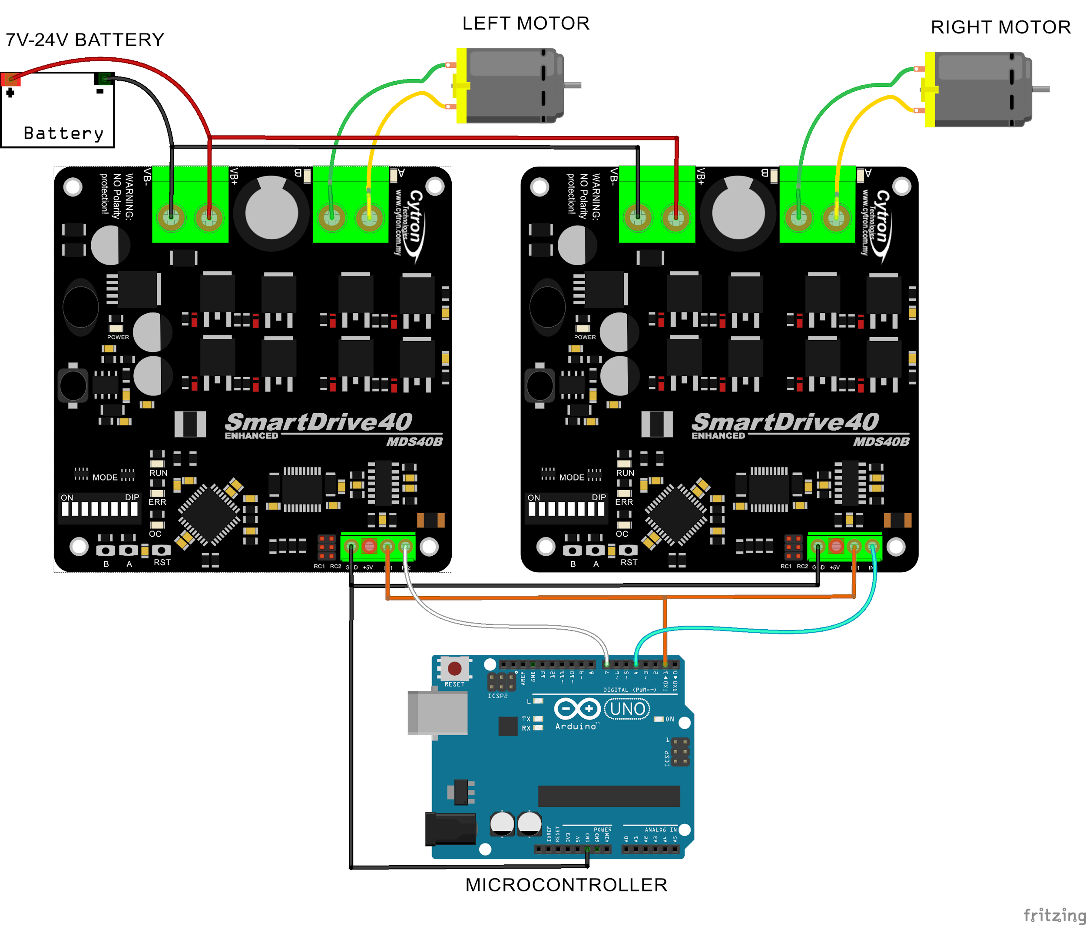

**8****.4 SERIAL PACKETIZED MODE**

In Packetized Serial mode, Enhanced SmartDrive40 is controlled by using the UART interface. DIG1 pin is the UART Rx pin. DIG2, AN1 and AN2 pins are not used in this mode. To control the motor, data sent to the driver must be in 4 bytes packet format which includes a header, address, command and checksum. Up to 8 units of Enhanced SmartDrive40 can be connected together to a single microcontroller UART Tx pin.

Besides that, the Enhanced SmartDrive40 also incorporates an Auto-Baud feature in Packetized Serial mode. When the driver is first powered up, the host microcontroller must send a header byte (Decimal 85 or hex 55) once to the driver. The driver will then calculate the baud rate automatically based on this byte. After that, Enhanced SmartDrive40 is ready to read full packet (4 bytes) and the baud rate cannot be changed without power recycle (power off and on) or reset button.

|  |
| --- |
| **NOTE:**   1. When the driver is powered up and waiting for the header byte, the error LED will blink and indicate that there is input error. 2. Enhanced SmartDrive40 may take up to 500ms to start up after power is applied. Sending the header byte for auto baud during this time period may cause undesirable results. Please allow one-second delay between applying power and sending the header byte. |

Packetized Serial mode is selected by setting **SW1, SW2 and SW3** to **1 (Up)**. SW4 – SW6 are used to select the address.

|  |  |  |
| --- | --- | --- |
| Input Mode | **SW1 - SW3**  111 | **Packetized Serial Mode** |
| UART Address | **SW4 - SW6**  000 - 111 | **0 - 7** |

0 - OFF 1 - ON X - Don’t Care

A packet consists of 4 bytes and the format is shown in the following table.

|  |  |  |  |
| --- | --- | --- | --- |
| **Byte** | **Name** | **Value (Decimal)** | **Description** |
| 1 | Header | 85 | To indicate the start of packet. |
| 2 | Address | 0 - 7 | Used to identify the driver when multiple units are connected together. The address bits (bit 2 - 0) must match the address configured with the DIP switch. |
| 3 | Command | 0 – 255 | Value 127 stops the motor, 0 is full reverse and 255 is full forward. |
| 4 | Checksum | 0 – 255 | The value for checksum must be the result of  Header + Address + Command |

Figure below shows the connection to multiple drivers in Packetized Serial Mode.

Packetized Serial mode with microcontroller (Address = 0), DIP switch

**DIP Switch Setting**

1 2 3 4 5 6 7 8

**1 1 1 0 0 0 0 0**

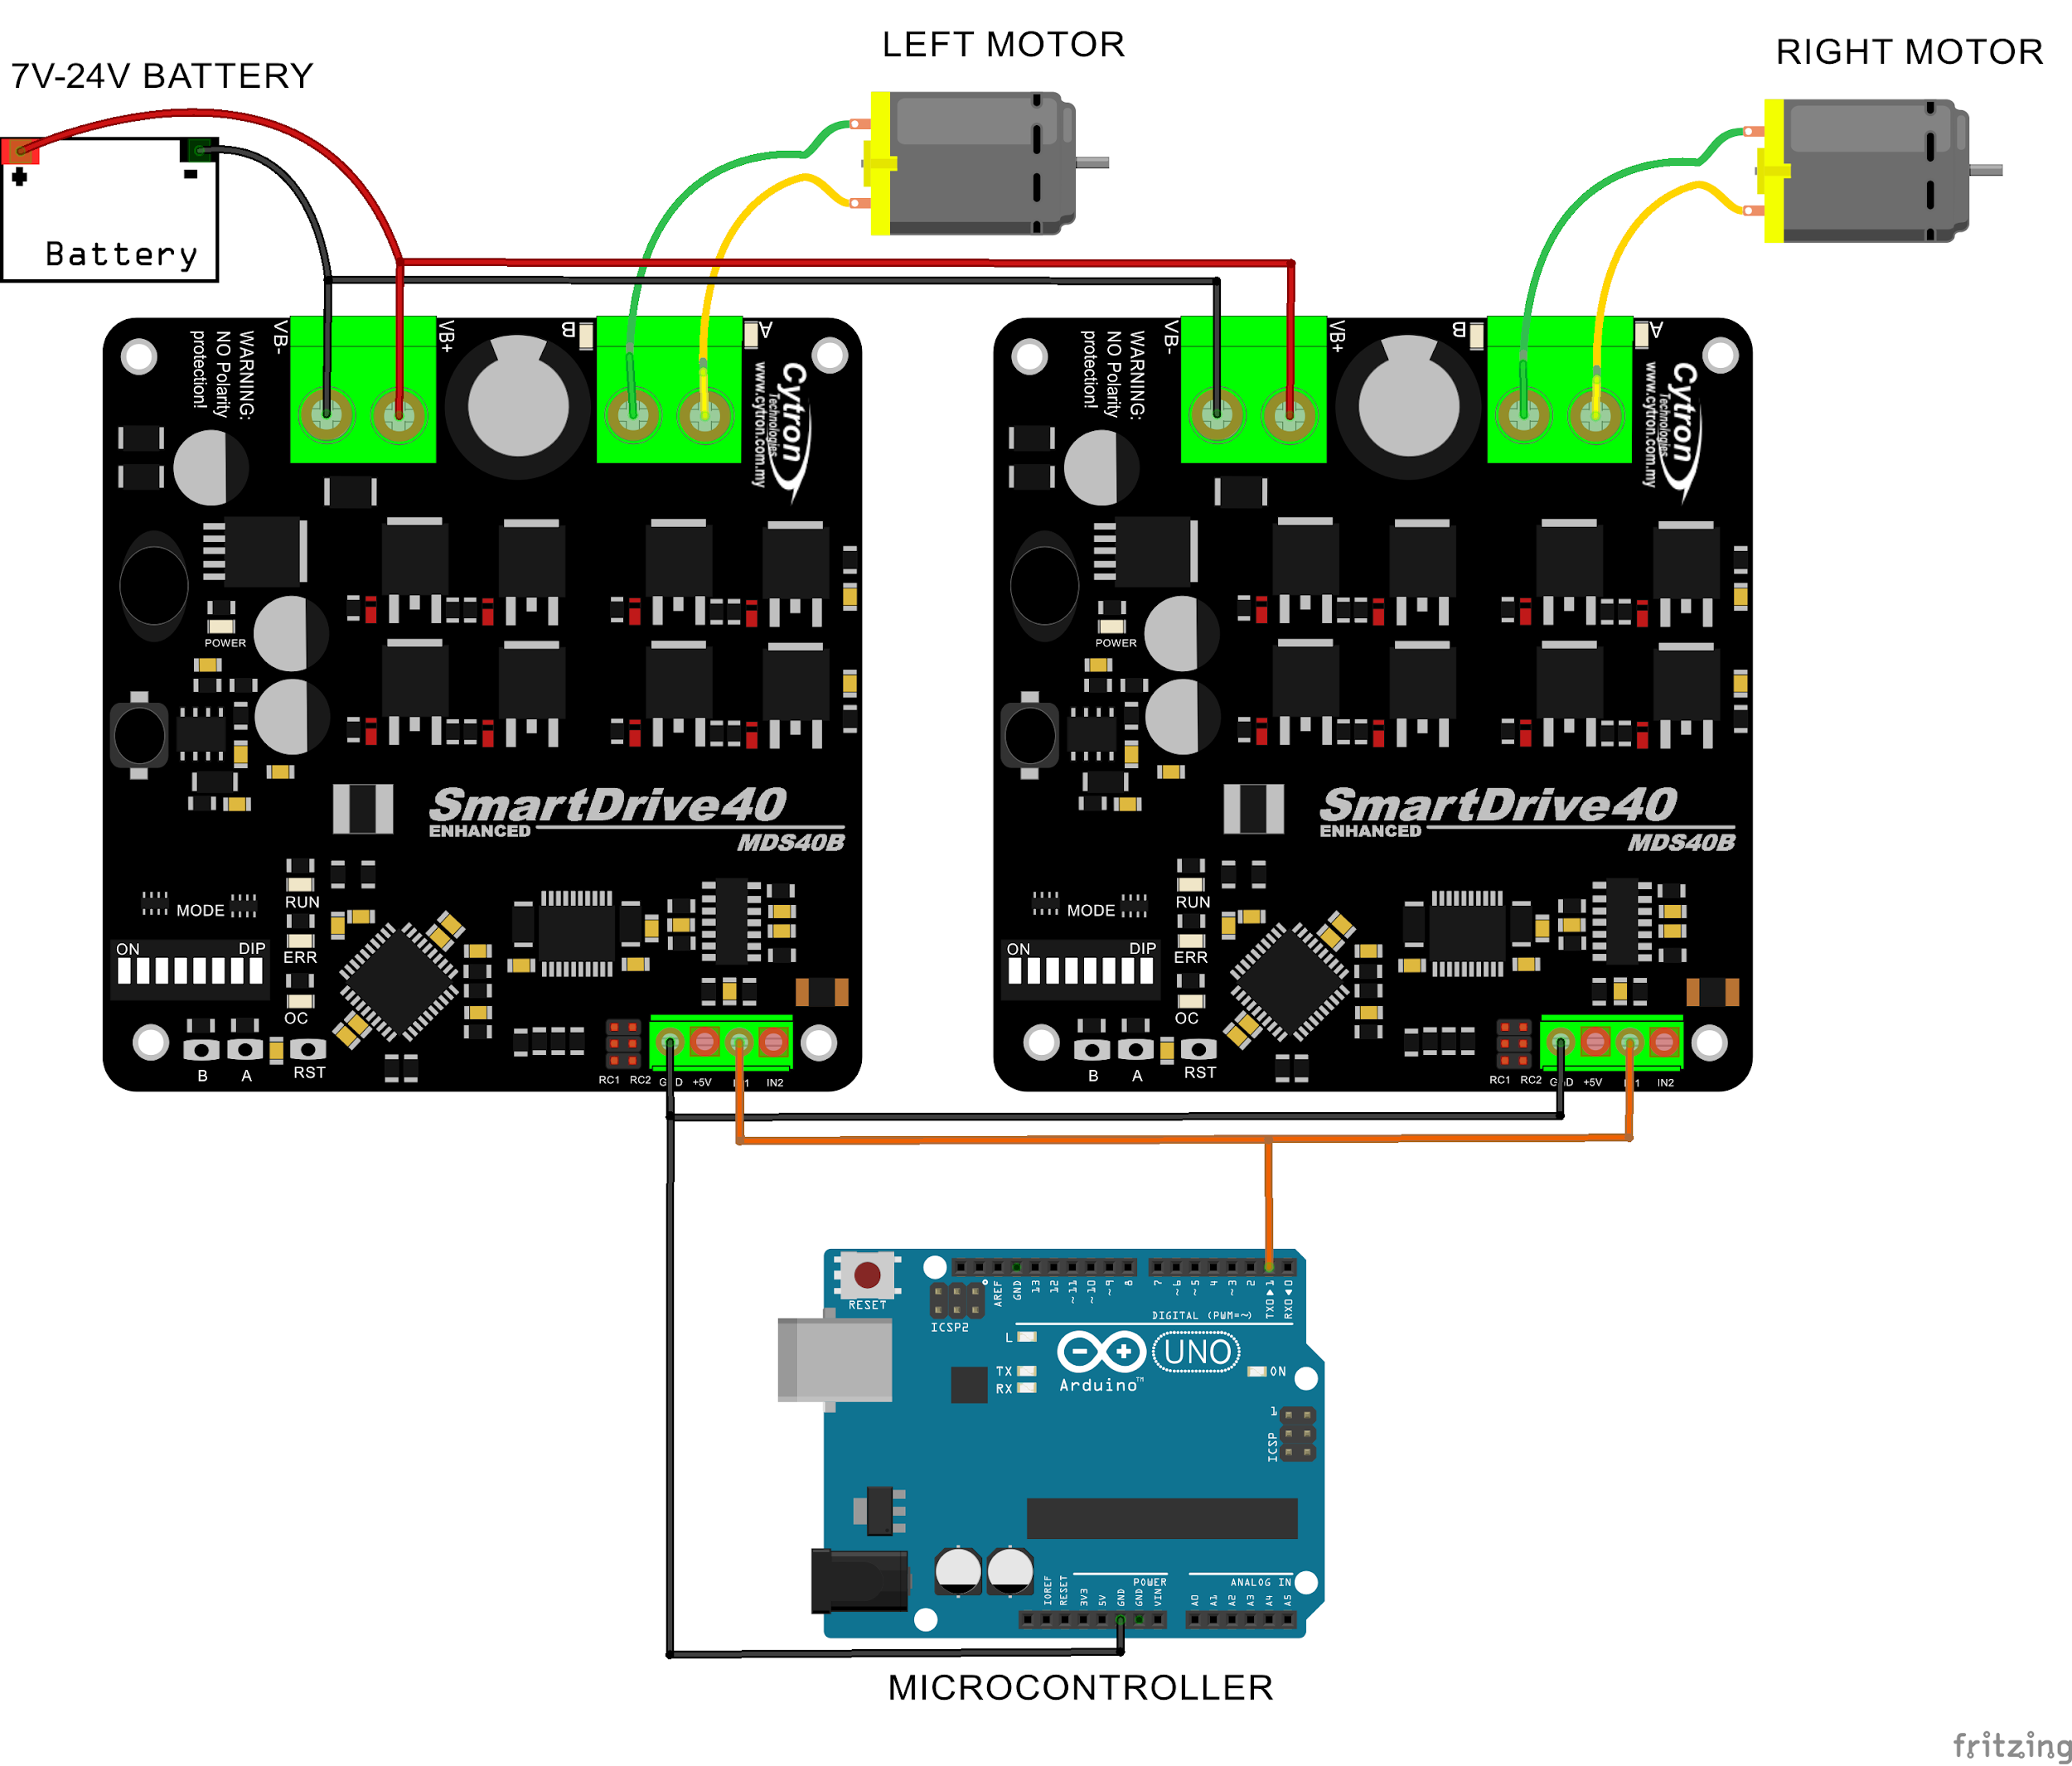

**9****. WARRANTY**

* Product warranty is valid for 12 months.
* Warranty only applies to manufacturing defect.
* Damaged caused by misuse is not covered under warranty
* Warranty does not cover freight cost for both ways.

*Prepared by:*

***Cytron Technologies Sdn. Bhd.***

No. 16, Jalan Industri Ringan Permatang Tinggi 2,

Kawasan Industri Ringan Permatang Tinggi,

14100 Simpang Ampat,

Penang, Malaysia.

*Tel: +604 - 504 1878*

*Fax: +604 - 504 0138*

*URL:* [www.cytron.com.my](http://www.cytron.com.my/)

*Email:* [support@cytron.com.my](mailto:support@cytron.com.my)

[sales@cytron.com.my](mailto:sales@cytron.com.my)